**New to OR Conference 2019**

**(In-person)**

**OR Society's 60th Annual Conference (In-person)**

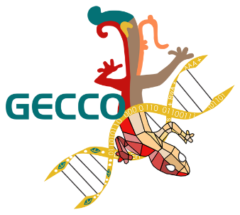

**GECCO 2020 (Online)**

**@Cancun, Mexico**

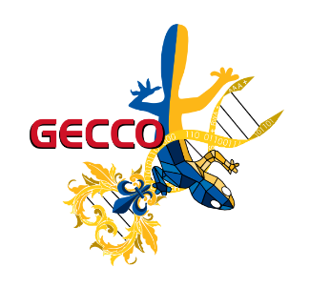

**GECCO 2021 (Online)**

**@Lille, France**

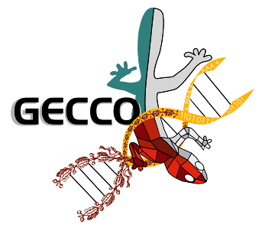

**GECCO 2022 (Hybrid)**

**@Boston, USA**

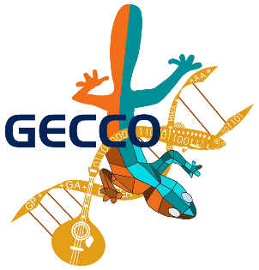

**GECCO 2023 (Hybrid)**

**@Lisbon, Portugal**

**GECCO 2025 (Hybrid)**

**@Malaga, Spain**



**42nd International Symposium on Forecasting (In-person)**

